

Year 7
Semester 1
Statistics Investigation

Your task is to create an informative poster presentation based on the collection and interpretation of data towards addressing a practical research question for the topic:
How Far Does Water Travel?
Background Information
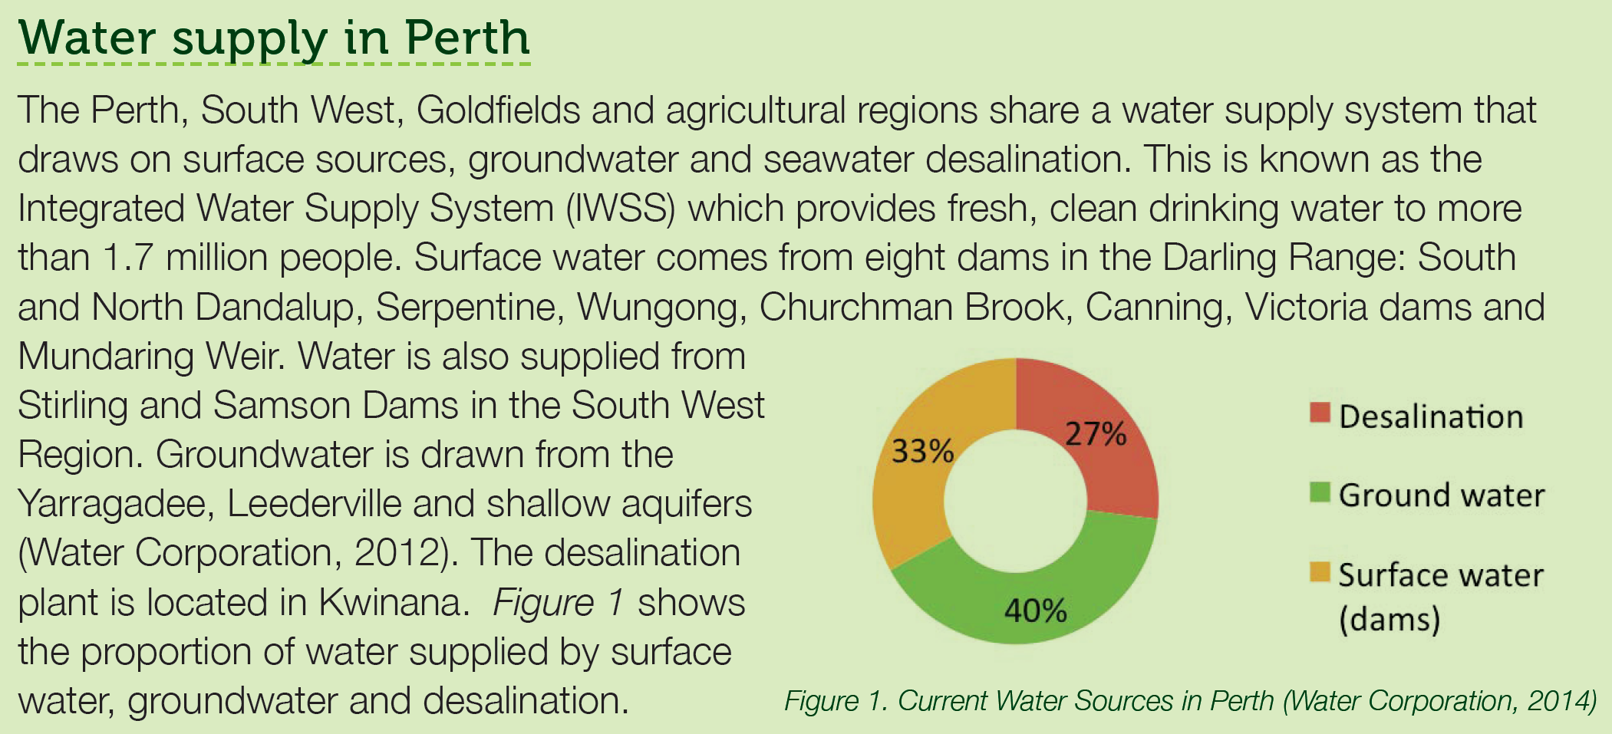
Table 1: Source of Bottled Water
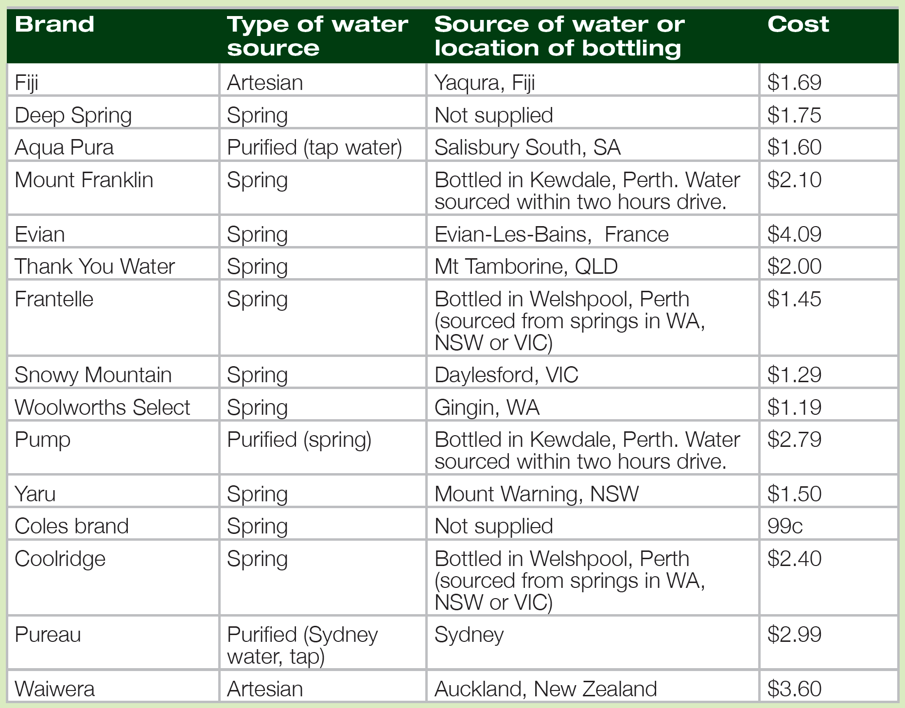

Poster Details
The poster will be completed by small groups of 3-4 people on the topic, How Far Does Water Travel?. This will be a poster that can be placed up on the walls of the classroom, so the information needs to be able to be read from a distance.

Planning
Group Members

Step 1 – Interpret the task and gather information
What is the problem that needs to be solved?

What information do you need to consider or include as part of the problem?

Do you have a prediction of what your results will show? This is your hypothesis. It is usually 1 sentence.

State the problem that you are solving and the information included in your problem in 1 – 2 paragraphs.

Step 2 – Identify the Mathematics that could help answer the problem
List some questions that you need to answer using mathematics to help solve the problem.
- Hints:
  - How far are the dams from your home?
  - How far is the desalination plant in Kwinana from your home?
  - How far are the groundwater sources, (Yarragadee and Leederville), from your home?
  - How will you display this information? Will you use tables? What type of graphs will you use? Can a Dot Plot or Stem and Leaf Plot help display information?
  - What statistical analysis, (mean, mode, median, range), will you use?

Explain how your choices of mathematical strategies will help you solve the problem.

Step 3 – Analyse information and data from a range of sources
Where will you collect reliable information and data from? (What websites will have the information you are looking for?)
Where can you collect primary sources of information or data from? (Can you conduct a survey?)
How can you share the tasks in your group, so everyone does their fair share of work?

Step 4 – Apply existing mathematical knowledge and strategies to obtain a solution
Show your mathematical working out. Are there any tables of data or graphs that you need to include?
How can you share the tasks in your group, so everyone does their fair share of work? (You will need more space than what has been provided here on this planning sheet.)

Step 5 – Check that your solutions make sense.
As a group check the working out. Do you all agree with the working out? Is it correct? Are the answers realistic? Is there any result that needs further investigation?

Step 6 – Conclusion
State your final answer. Discuss possible sources of error, interesting facts learned and possible areas for further research if you had time or how you would improve your investigation if you were to do it again.

POSTER CHECKLIST

- Clarity of the message:
  - Is the poster understandable without extra information?
  - Are the objectives, research question or hypotheses clear?
  - Are the results and conclusions clear?
  - Is the poster clearly and logically set out?

- Data collection:
  - Are the collected data appropriate for answering the research question?
  - Are the data collection methods clearly stated?
  - Has quality of the data been considered? (i.e., accuracy of measurements, size of the sample, reliability of sources, methods of sampling, etc.)
  - Are the data sources referenced in the poster?
  - Are the sporting results included in the table of results?
  - Has bias in your survey question or sample group been considered?

- Graphs and tables:
  - Are the graphs/tables/statistics appropriate for displaying/summarising the data?
  - Are there adequate graphs/tables from different perspectives?
  - Does every graph/ table add something to the poster?
  - Are the graphs/tables properly titled and explained?

- Calculations
  - Have you included statistical calculations? (ie mean, mode, median, range, etc)

- Analysis and conclusions
  - Are the data analysed in terms of the research question or hypotheses?
  - Is the analysis appropriate for the kind of data collected?
  - How well is the research question answered?
  - Are there conclusions and are they supported by the data?
  - Are there any limitations discussed or improvements for future studies suggested?

- Presentation of poster:
  - Is the poster readable from 2 metres (7 feet) away?
  - Is there a good balance between graphs and text?
  - Does the poster look neat?

- Creativity/importance:
  - Is the research question creative, original?
  - Can the study answer an interesting question?
  - Is the design creative and original?
  - Is the poster eye-catching?

- Presentation of poster:
  - Are you prepared to present the poster to the rest of the class?

